**Applied Data Science Capstone Project**

What’s the best location to set up a high-end coffee shop in Chicago?

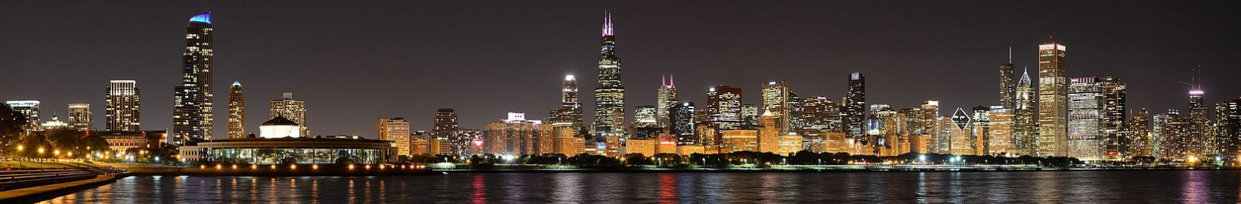

***Introduction/Business problem:***

Chicago is a great city to start new business ventures.

It welcomed nearly 60 Million domestic and international visitors in 2018, making it the second most visited city in the nation after New York.

Chicago counts almost 3M residents, and numerous universities and work places.

When it comes to set up a new business, like a high-end coffee shop, in a city like Chicago, choosing the right location can be overwhelming. There are so many factors to take into account, like competition. Depending on who you want to cater to, you might want to set up your new venture in a touristic location, near a university or college, or nearby work places.

This project proposes to identify the best location / neighborhood to set up a new coffee shop in Chicago. This will be done calling the Foursquare api to retrieve existing venues in all Chicago neighborhood, and then by applying a scoring model to make the recommendations.

***Data:***

We will be using different sources of data to complete the project:

* Chicago list of neighborhoods: Data will be collected by scraping the Wikipedia page *https://en.wikipedia.org/wiki/List_of_neighborhoods_in_Chicago*
* OpenStreetMap Data: We’ll use Nominatim, the search engine for OpenStreetMap data, to retrieve the GPS coordinates for the list of Chicago neighborhoods
* Foursquare data : We’ll query the Foursquare APIs to extract venues of interest (ex: Coffee Shops, Work Places, Universities…) and their location.

As a result of merging and analyzing this data, we’ll provide a neighborhood of preference as an output, to set up a new high-end coffee shop.